MRS. MERINO’s SCIENCE CLASS. WEEK 7

ANSWER THE FOLLOWING 7 QUESTIONS RELATING TO GLOBAL WARMING. DUE 5/29/2020

[What Is Global Warming?](https://www.nrdc.org/stories/global-warming-101#warming)

[What Causes Global Warming?](https://www.nrdc.org/stories/global-warming-101#causes)

[How Is Global Warming Linked to Extreme Weather?](https://www.nrdc.org/stories/global-warming-101#weather)

[What Are the Other Effects of Global Warming?](https://www.nrdc.org/stories/global-warming-101#effects)

[Where Does the United States Stand in Terms of Global-Warming Contributors?](https://www.nrdc.org/stories/global-warming-101#contribute)

[Is the United States Doing Anything To Prevent Global Warming?](https://www.nrdc.org/stories/global-warming-101#prevention)

[Is Global Warming Too Big of a Problem for Me to Help Tackle?](https://www.nrdc.org/stories/global-warming-101#tackle)

<img typeof="foaf:Image" src="https://assets.nrdc.org/sites/default/files/styles/full_content/public/media-uploads/clis11_cmw42d_2400.jpg?itok=Foaue_b0" width="634" height="410" alt="" />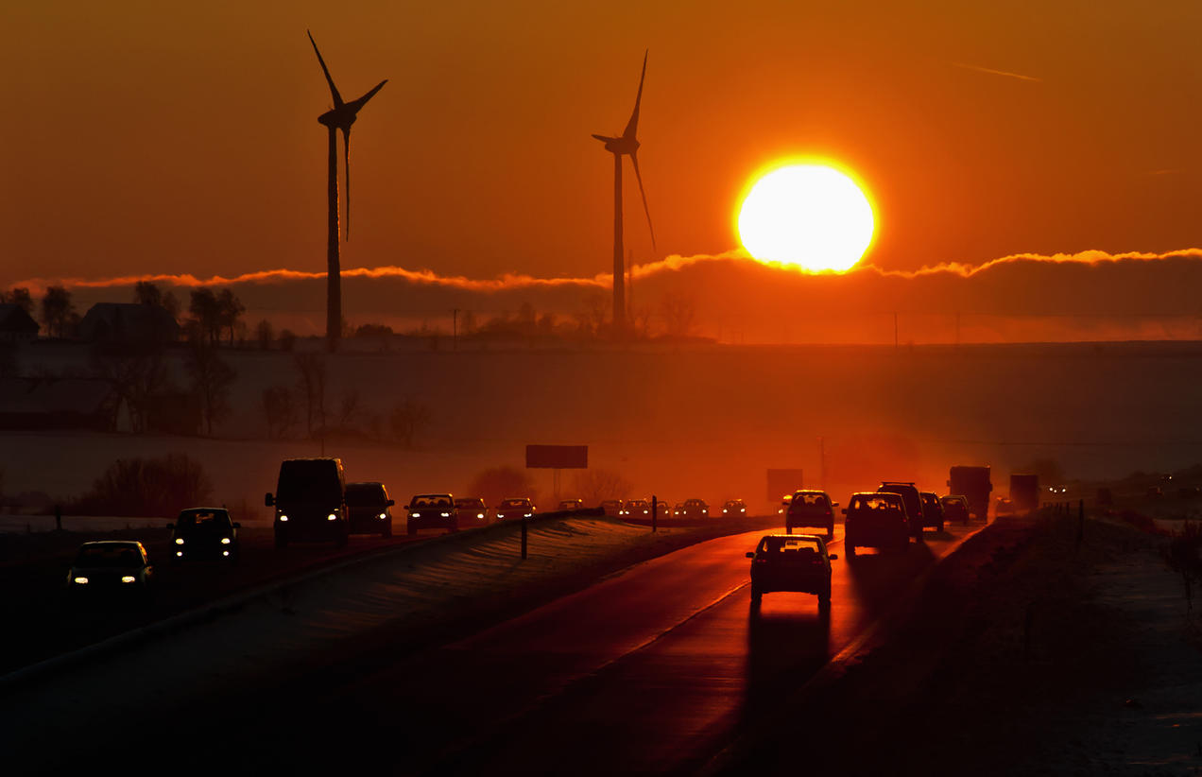

Håkan Jansson/Alamy

Q: What is global warming?

A: Here's a simple definition of global warming. (And yes, it's really happening.) Over the past 50 years, the average global temperature has increased at the fastest rate in recorded history. And experts see the trend is accelerating: All but one of the 16 hottest years in NASA’s 134-year record have occurred [since 2000](https://www.ncdc.noaa.gov/sotc/global/201513).

Climate change deniers have argued that there has been a “pause” or a “slowdown” in rising global temperatures, but several recent studies, including a [2015 paper](http://science.sciencemag.org/content/348/6242/1469) published in the journal Science, have disproved this claim. And scientists say that unless we curb global-warming emissions, average U.S. temperatures could increase by up to 10 degrees Fahrenheit over the next century.

Q: What causes global warming?

A: Global warming occurs when carbon dioxide (CO2) and other air pollutants and greenhouse gases collect in the atmosphere and absorb sunlight and solar radiation that have bounced off the earth’s surface. Normally, this radiation would escape into space—but these pollutants, which can last for years to centuries in the atmosphere, trap the heat and cause the planet to get hotter. That's what's known as the greenhouse effect.

In the United States, the burning of fossil fuels to make electricity is the largest source of heat-trapping pollution, producing about two billion tons of CO2 every year. Coal-burning power plants are by far the biggest polluters. The country’s second-largest source of carbon pollution is the transportation sector, which generates about 1.7 billion tons of CO2 emissions a year.

[[](https://act.nrdc.org/letter/climate-assessment-181130?source=WBSNCAPET)](https://act.nrdc.org/letter/climate-assessment-181130?source=WBSNCAPET)

Tell President Trump we demand immediate action on climate change

[Take Action](https://act.nrdc.org/letter/climate-assessment-181130?source=WBSNCAPET)

Curbing dangerous [climate change](https://www.nrdc.org/issues/climate-change) requires very deep cuts in emissions, as well as the use of alternatives to fossil fuels worldwide. The good news is that we’ve started a turnaround: CO2 emissions in the United States actually decreased from 2005 to 2014, thanks in part to new, energy-efficient technology and the use of cleaner fuels. And scientists continue to develop new ways to modernize power plants, generate cleaner electricity, and burn less gasoline while we drive. The challenge is to be sure these solutions are put to use and widely adopted.

Q: How is global warming linked to extreme weather?

A: Scientists agree that the earth’s rising temperatures are fueling longer and hotter heat waves, more frequent droughts, heavier rainfall, and more powerful hurricanes. In 2015, for example, scientists said that an ongoing drought in California—the state’s worst water shortage in 1,200 years—had been intensified by 15 percent to 20 percent by global warming. They also said the odds of similar droughts happening in the future had roughly doubled over the past century. And in 2016, the National Academies of Science, Engineering, and Medicine announced that it’s now possible to confidently attribute certain weather events, like some heat waves, directly to climate change.

The earth’s ocean temperatures are getting warmer, too—which means that tropical storms can pick up more energy. So global warming could turn, say, a category 3 storm into a more dangerous category 4 storm. In fact, scientists have found that the frequency of North Atlantic hurricanes has [increased](http://nca2014.globalchange.gov/report/our-changing-climate/changes-hurricanes) since the early 1980s, as well as the number of storms that reach categories 4 and 5. In 2005, Hurricane Katrina—the costliest hurricane in U.S. history—struck New Orleans; the second-costliest, Hurricane Sandy, hit the East Coast in 2012.

The impacts of global warming are being felt across the globe. Extreme heat waves have caused tens of thousands of deaths around the world in recent years. And in an alarming sign of events to come, Antarctica has been losing about 134 billion metric tons of ice per year since 2002. This rate could speed up if we keep burning fossil fuels at our current pace, some experts say, causing sea levels to rise several meters over the next 50 to 150 years.

Q: What are the other effects of global warming?

A: Each year, scientists learn more about the [consequences of global warming](https://www.nrdc.org/stories/are-effects-global-warming-really-bad), and many agree that environmental, economic, and health consequences are likely to occur if current trends continue. Here’s just a smattering of what we can look forward to:

Melting glaciers, early snowmelt, and severe droughts will cause more dramatic water shortages and increase the risk of wildfires in the American West.

Rising sea levels will lead to coastal flooding on the Eastern Seaboard, especially in Florida, and in other areas such as the Gulf of Mexico.

Forests, farms, and cities will face troublesome new pests, heat waves, heavy downpours, and increased flooding. All those factors will damage or destroy agriculture and fisheries.

Disruption of habitats such as coral reefs and Alpine meadows could drive many plant and animal species to extinction.

Allergies, asthma, and infectious disease outbreaks will become more common due to increased growth of [pollen-producing ragweed](https://www.nrdc.org/climate-change-and-health-air-quality), higher levels of [air pollution](https://www.nrdc.org/stories/air-pollution-everything-you-need-know), and the spread of conditions favorable to pathogens and mosquitoes.

Q: Where does the United States stand in terms of global-warming contributors?

A: In recent years, China has taken the lead in global-warming pollution, producing about [28 percent](https://www3.epa.gov/climatechange/ghgemissions/global.html#four) of all CO2 emissions. The United States comes in second. Despite making up just 4 percent of the world’s population, we produce a whopping 16 percent of all global CO2 emissions—as much as the European Union and India (third and fourth place) combined. And America is still number one, by far, in eekcumulative emissions over the past 150 years. Our responsibility matters to other countries, and it should matter to us, too.

Q: Is the United States doing anything to prevent global warming?

A: We’ve started. But in order to avoid the worst effects of climate change, we need to do a lot more—together with other countries—to reduce our dependence on fossil fuels and start using clean energy instead.

In 2015, the U.S. Environmental Protection Agency pledged to reduce carbon pollution from our power plants by nearly a third by 2030, relative to 2005 levels, through its [Clean Power Plan](https://www.nrdc.org/stories/how-clean-power-plan-works-and-why-it-matters). But fast-forward to 2017, and under the Trump Administration, the EPA [proposed repealing](https://www.nrdc.org/media/2017/171009) this critical tool for curbing climate change. Likewise, while under the Obama administration, the U.S. Department of Transportation proposed carbon pollution and fuel economy standards intended to cut emissions through the 2020s, under Trump administration, the DOT is working to [roll back those clean vehicle safeguards](https://www.nrdc.org/experts/luke-tonachel/states-boost-trump-rolls-back-clean-vehicles-2017) that protect the climate and our health.

Fortunately, state leaders—including in [car country](https://www.nrdc.org/experts/luke-tonachel/ohio-indiana-tennessee-want-strong-fuel-economy-standards) itself—recognize that clean transportation must remain a priority if we are to address the costly risks of climate change and protect public health. And regional efforts around the country are helping to [boost the electric car market](https://www.nrdc.org/experts/luke-tonachel/states-boost-trump-rolls-back-clean-vehicles-2017), which saw an increase in sales for 2017 over 2016. Our [clean energy economy is growing](https://www.nrdc.org/experts/elizabeth-noll/state-clean-energy-strong) too, despite federal efforts to derail it. In 2016, wind employment grew by 32 percent and solar jobs increased by 25 percent.

Globally, at the United Nations Conference on Climate Change in Paris, 195 countries—including the United States, at the time—agreed to pollution-cutting provisions with a goal of preventing the average global temperature from rising more than 1.5 degrees Celsius above preindustrial times. (Scientists say we must stay below a two-degree increase to avoid catastrophic climate impacts.)

To help make the deal happen, the Obama administration pledged $3 billion to the Green Climate Fund, an international organization dedicated to helping poor countries adopt cleaner energy technologies. Under the terms of the Paris agreement, participating nations will meet every five years, starting in 2020, to revise their plans for cutting CO2 emissions. Beginning in 2023, they will also have to publicly report their progress.

While in 2017, President Trump announced the country’s withdrawal from the Paris climate agreement and to eliminate “harmful and unnecessary policies such as the Climate Action Plan,” Americans are forging ahead without him. Through initiatives like the United States Climate Alliance, the Regional Greenhouse Gas Initiative, We Are Still In, and Climate Mayors, state, business, and local leaders have pledged to honor and uphold the goals of the Paris Agreement. More than 25 cities in 17 states, with populations totaling more than 5 million have [adopted resolutions](https://www.nrdc.org/experts/shelley-poticha/cities-stand-united-paris-agreement-cop-23) that will enable them to get 100 percent of their electricity from renewable sources like wind and solar.

Even better, a new [initiative](https://www.nrdc.org/experts/nrdc/race-save-our-planet-bloomberg-announces-multimillion-dollar-city-climate-challenge) by former New York City mayor Michael Bloomberg gives the urban layer of this movement a boost. He’s asked mayors from the 100 most populous cities in the country to share their plans for making their buildings and transportation systems run cleaner and more efficiently. The 20 that show the greatest potential for cutting the dangerous carbon pollution that’s driving climate change will share a total of $70 million in technical assistance funding provided by [Bloomberg Philanthropies](https://www.bloomberg.org/) and partners.

Q: Is global warming too big of a problem for me to help tackle?

A: Wondering [how to stop global warming](https://www.nrdc.org/stories/how-you-can-stop-global-warming)? Reduce your own carbon footprint by following a few easy steps. Make conserving energy a part of your daily routine and your decisions as a consumer. When you shop for new appliances like refrigerators, washers, and dryers, look for products with the government’s Energy Star label; they meet a higher standard for energy efficiency than the minimum federal requirements. When you buy a car, look for one with the highest gas mileage and lowest emissions. You can also reduce your emissions by taking public transportation or carpooling when possible.

And while new federal and state standards are a step in the right direction, much more needs to be done. [Voice your support](https://secure.nrdconline.org/site/Advocacy?cmd=display&page=UserAction&id=3819&s_src=WBLCPPPETNONFORM) of climate-friendly and climate change preparedness policies, and tell your representatives that transitioning from dirty fossil fuels to clean power should be a top priority—because it’s vital to building healthy, more secure communities.

[[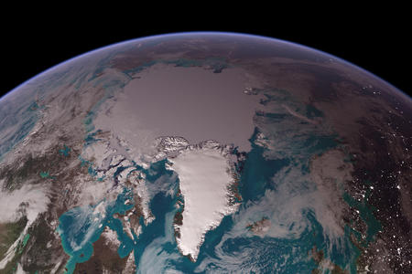](https://www.nrdc.org/demand-climate-action)](https://www.nrdc.org/demand-climate-action)

Demand Climate Action

[Learn More](https://www.nrdc.org/demand-climate-action)

Related Stories

[[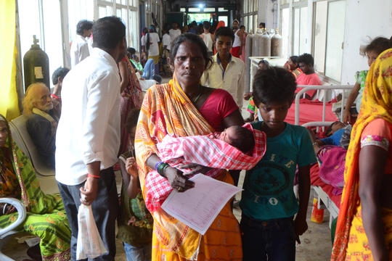](https://www.nrdc.org/stories/temperatures-soar-india-one-citys-efforts-are-saving-lives)](https://www.nrdc.org/stories/temperatures-soar-india-one-citys-efforts-are-saving-lives)

NRDC in Action

[As Temperatures Soar in India, One City’s Efforts Are Saving Lives](https://www.nrdc.org/stories/temperatures-soar-india-one-citys-efforts-are-saving-lives)

The western city of Ahmedabad is preparing residents to cope with the longer and more intense heat waves sweeping across South Asia—and inspiring other Indian cities and states to follow suit.

[[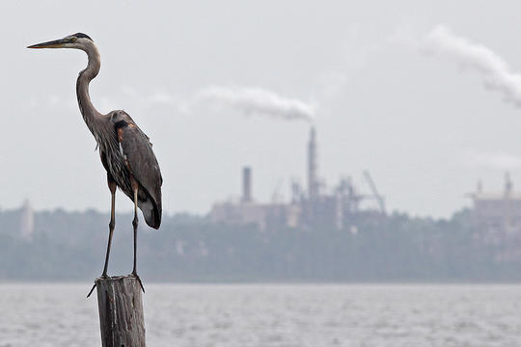](https://www.nrdc.org/stories/greenhouse-effect-101)](https://www.nrdc.org/stories/greenhouse-effect-101)

Guide

[Greenhouse Effect 101](https://www.nrdc.org/stories/greenhouse-effect-101)

By increasing the concentration of greenhouse gases in the atmosphere, we’re amplifying the planet’s natural greenhouse effect and turning up the dial on global warming.

[[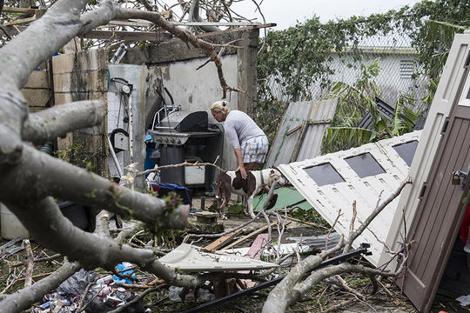](https://www.nrdc.org/stories/hurricanes-and-climate-change-everything-you-need-know)](https://www.nrdc.org/stories/hurricanes-and-climate-change-everything-you-need-know)

Guide

[Hurricanes and Climate Change: Everything You Need to Know](https://www.nrdc.org/stories/hurricanes-and-climate-change-everything-you-need-know)

The most widespread, damaging storms on earth are getting worse, and climate change is a big reason why. Here’s a look at what causes hurricanes and how to address the threat of a wetter, windier world.

[[](https://www.nrdc.org/stories/ipcc-climate-change-report-why-it-matters-everyone-planet)](https://www.nrdc.org/stories/ipcc-climate-change-report-why-it-matters-everyone-planet)

Guide

[The IPCC Climate Change Report: Why It Matters to Everyone on the Planet](https://www.nrdc.org/stories/ipcc-climate-change-report-why-it-matters-everyone-planet)

The U.N. report warns that dire impacts from climate change will arrive sooner than many expected. Here’s why we need to follow the report’s advice, and why every ton of emissions reductions can make a difference.

[[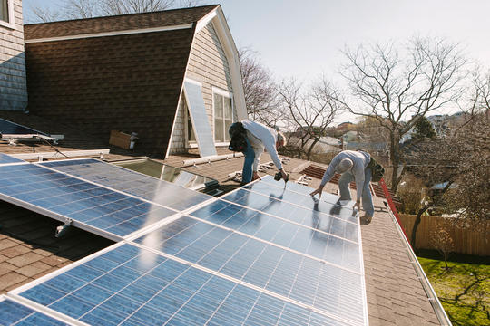](https://www.nrdc.org/stories/how-you-can-stop-global-warming)](https://www.nrdc.org/stories/how-you-can-stop-global-warming)

Explainer

[How You Can Stop Global Warming](https://www.nrdc.org/stories/how-you-can-stop-global-warming)

Healing the planet starts at home—in your garage, in your kitchen, and at your dining-room table.

[[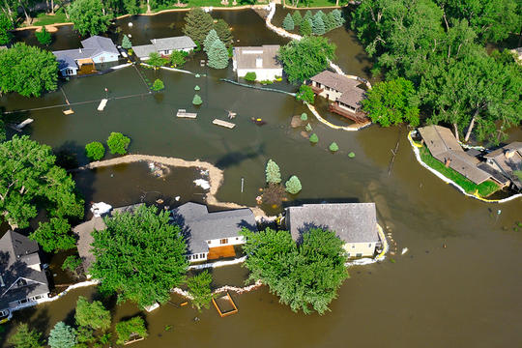](https://www.nrdc.org/stories/are-effects-global-warming-really-bad)](https://www.nrdc.org/stories/are-effects-global-warming-really-bad)

Explainer

[Are the Effects of Global Warming Really that Bad?](https://www.nrdc.org/stories/are-effects-global-warming-really-bad)

Short answer: Yes. Even a seemingly slight average temperature rise is enough to cause a dramatic transformation of our planet.

[[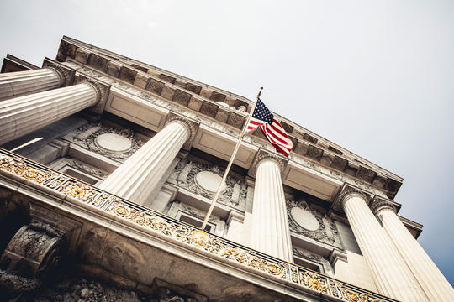](https://www.nrdc.org/stories/5-ways-city-dwellers-can-spur-climate-action)](https://www.nrdc.org/stories/5-ways-city-dwellers-can-spur-climate-action)

Personal Action

[5 Ways City Dwellers Can Spur Climate Action](https://www.nrdc.org/stories/5-ways-city-dwellers-can-spur-climate-action)

What is your city doing about climate change? Ask your local leaders these five questions.

[[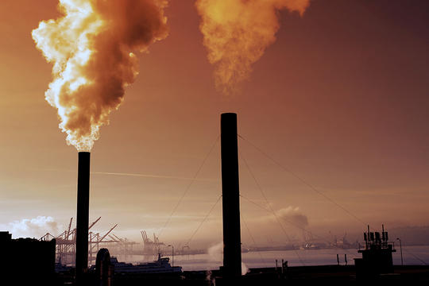](https://www.nrdc.org/stories/air-pollution-everything-you-need-know)](https://www.nrdc.org/stories/air-pollution-everything-you-need-know)

Guide

[Air Pollution: Everything You Need to Know](https://www.nrdc.org/stories/air-pollution-everything-you-need-know)

How smog, soot, greenhouse gases, and other top air pollutants are affecting the planet—and your health.

[[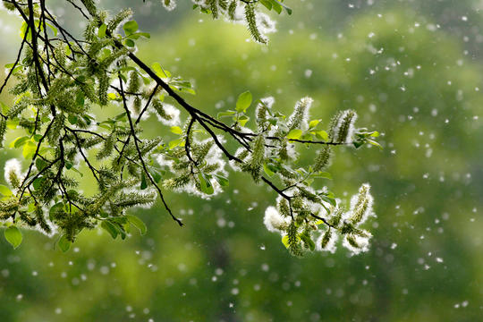](https://www.nrdc.org/stories/climate-change-air)](https://www.nrdc.org/stories/climate-change-air)

Personal Action

[Climate Change Is In the Air](https://www.nrdc.org/stories/climate-change-air)

As temperatures and carbon levels rise, even breathing has become a challenge. Here’s what you can do to help clear the air.

[[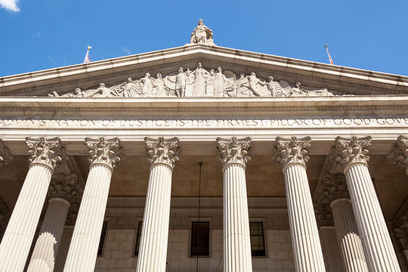](https://www.nrdc.org/stories/can-i-participate-class-action-lawsuit-against-climate-change-inaction)](https://www.nrdc.org/stories/can-i-participate-class-action-lawsuit-against-climate-change-inaction)

Q&A

[Can I Participate in a Class-Action Lawsuit Against Climate Change Inaction?](https://www.nrdc.org/stories/can-i-participate-class-action-lawsuit-against-climate-change-inaction)

NRDC senior attorney Ben Longstreth explains how plaintiffs for these cases get chosen—and how you can help advance the cause in or out of the courtroom.

[[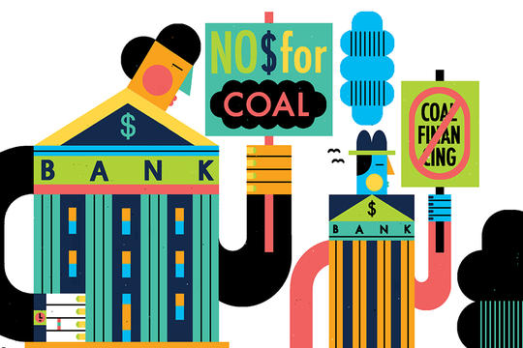](https://www.nrdc.org/stories/if-government-wont-act-climate-maybe-banks-will)](https://www.nrdc.org/stories/if-government-wont-act-climate-maybe-banks-will)

Explainer

[If the Government Won’t Act on Climate, Maybe Banks Will](https://www.nrdc.org/stories/if-government-wont-act-climate-maybe-banks-will)

Gun-control activists want to use financial levers to curtail firearm sales. Can we do the same for carbon emissions?

Support Our Work

Top of Form

$35 $50 $75 $100 $200 Other 

[Donate](javascript:void(0);)

Bottom of Form

Join Us

Top of Form

Email *



Thanks for signing up. You'll receive your first NRDC action alert and update email soon.



Bottom of Form

When you sign up you'll become a member of NRDC's Activist Network. We will keep you informed with the latest alerts and progress reports.

[About Us](https://www.nrdc.org/about)

[Careers](https://www.nrdc.org/careers)

[Contact Us](https://www.nrdc.org/contact-us)

[Media Center](https://www.nrdc.org/media)

[Policy Library](https://www.nrdc.org/policy-library)

[Sitemap](https://www.nrdc.org/sitemap)

[En Español](https://www.nrdc.org/node/24354)

[Privacy Policy](https://www.nrdc.org/privacy-policy)

Follow Us

[Twitter](https://twitter.com/nrdc)

[Facebook](https://www.facebook.com/nrdc.org)

[YouTube](https://www.youtube.com/user/NRDCflix)

[instagram](https://www.instagram.com/nrdc_org/)

[RSS](https://www.nrdc.org/rss.xml)

© Natural Resources Defense Council 2020 [Privacy Policy](https://www.nrdc.org/privacy-policy) [State Disclosures](https://www.nrdc.org/state-disclosures)

<img height="1" width="1" style="display:none" src="https://www.facebook.com/tr?id=180130112355994&amp;ev=PageView&amp;noscript=1"> <iframe src="//20750798p.rfihub.com/ca.html?rb=28189&amp;ca=20750798&amp;_o=28189&amp;_t=20750798&amp;ra=YOUR_CUSTOM_CACHE_BUSTER" style="display:none;padding:0;margin:0" width="0" height="0">< /iframe>

<img src="//bat.bing.com/action/0?ti=5523006&amp;Ver=2" height="0" width="0" style="display:none; visibility: hidden;">

<img height="1" width="1" style="display:none" src="https://www.facebook.com/tr?id=238841392971528&amp;ev=CompleteRegistration&amp;noscript=1">